Finishing & Packaging (FIN)

Scope Note

Stakeholders
- Food Quality Control Department
- Maintenance Department
- Health Monitor
- Logistics Scheduler and Transport Department
- Production operators handling rejected cakes and held product

Needs, Goals, and Objectives
- Need: Cooled cakes arriving from Thermal Processing must be turned into inspected, packed pallets ready for shipment.
- Goal: Only safe and legally compliant cakes leave the system, and the flow keeps running when a station fails.
- Objectives: Inspect every cake by weight, appearance and metal; sort out non-compliant cakes; wrap, carton and palletise the rest; keep the pan loop supplied.

Drivers and Constraints
- Only cakes within the regulatory weight tolerance may pass inspection (UC13).
- Only cakes with no metal contamination, and that pass visual inspection, may proceed to packaging (UC13).
- Only properly wrapped cakes may proceed to shipping (UC14/15).
- Cakes may only be packaged at room temperature (UC10).
- Keep double the pans needed to fill the system (UC12).
- Services run in Docker containers
- Band sections are independently drivable
- Components report through the message bus
- Availability is the group's main quality attribute. Of the six failure cases in this slice, three (FC21, FC24, FC26) are handled by the system and three (FC22, FC23, FC25) need Maintenance.

Scenarios
- Nominal: a cooled cake arrives, is depanned, passes weight, visual and metal checks, is wrapped, cartoned, placed on a pallet, and the pallet is ready for shipment. Meanwhile, the pan is sent to be washed, dried, inspected for damages, and recycled into the flow.
- Off-Nominal:
  - metal found (FC24)
  - wrapping station breaks (FC25)
  - washing station breaks (FC23)
  - pan not properly washed (UC12)
  - washed pan is damaged (UC12)
  - cake stuck or broken during depanning (FC21)
  - depanning machine breaks (FC22)
  - cake fails the weight or visual check (FC24)
  - wrong case weight (FC26)
  - band halt or slow-down notified by the monitoring system (UC2, FC19, FC20)

External Interfaces
Signal name | Direction | Counterpart | FIN block | Carries | Source
Cooled cake | In | THM | Depanning Control | Cake in its pan, batch ID | UC10, UC11
Pan request | In | THM | Pan Stock Management | "Waiting for pan" message when no pan is at depositing | FC8
Pan for washing | In | THM | Pan Washing Control | Pans diverted after a wrong fill weight | FC9
Clean pan supply | Out | THM | Pan Stock Management | Clean pans, current stock level | UC12, FC23
Stop / resume pan admission | Out | THM | Holding Area Management | Stop when the holding area is full, resume after repair | FC25
Log, warning, error and discard events | Out | MON | Event Reporting | Reason, time, batch ID, metal-found flag | UC12, UC13, FC21, FC24, FC26
Machine status (heartbeat) | Out | MON | Health Reporting | Heartbeat / health state | FC22, FC28
Band state change | In | MON | Band-State Response | Halt, slow-down or restart of the band | UC2, FC19, FC20
Repair confirmed | In | MON | Depanning Control; Holding Area Management; Washing Catch-up | Machine ID, repaired | UC12, FC22, FC23, FC25
Pallet ready for shipment | Out | PLM | Pallet Packing Control | Pallet ID, cake count, batch IDs | UC16
THM = Thermal Processing; MON = Line Monitoring & Health and Band Transport; PLM = Production & Logistics Management.

Requirements
Req ID | Requirement | Rationale | Source (UC/FC) | Feature ID | Block ID(s)
FIN-REQ-01 | The system shall receive each cake in its pan, together with its batch ID, from Thermal Processing through the signal "Cooled cake". | Entry point of the slice; the batch ID is needed for traceability and recall. | UC10, UC11 | FIN-FEAT-01 | FIN-AF-01
FIN-REQ-02 | The system shall accept for depanning only cakes that Thermal Processing has released as having reached the safe internal temperature. | The cooling guarantee sits with Thermal Processing at the handoff (UC10 postcondition). | UC10 | FIN-FEAT-01 | FIN-AF-01
FIN-REQ-03 | The system shall associate every cake with its batch ID from arrival until the cake is placed on a pallet. | Batch traceability for recall; the batch IDs are reported when a pallet is ready. | UC10, UC11, UC16 | FIN-FEAT-01 | FIN-AF-02
FIN-REQ-04.1 | The system shall separate each baked cake from its pan. | Cake and pan must go their separate ways: the cake to inspection, the pan back into the pan loop. | UC11 | FIN-FEAT-01 | FIN-AF-01, FIN-FD-01
FIN-REQ-04.2 | The system shall route each depanned cake toward quality inspection.
FIN-REQ-04.3 | The system shall route each emptied pan toward the pan washing station.
FIN-REQ-05.1 | The system shall weigh every depanned cake. | Only cakes within the regulatory tolerance may pass inspection. | UC13 | FIN-FEAT-05 | FIN-AF-03, FIN-FD-02
FIN-REQ-05.2 | The system shall mark a cake as failed if its weight is outside the regulatory tolerance of the target weight.
FIN-REQ-06.1 | The system shall inspect the appearance of every cake. | Only cakes passing visual inspection may proceed to packaging. | UC13 | FIN-FEAT-06 | FIN-AF-04, FIN-FD-03
FIN-REQ-06.2 | The system shall mark a cake as failed if its appearance is unsatisfactory.
FIN-REQ-07.1 | The system shall scan every cake for metal contaminants. | Product safety; only cakes without metal contamination may proceed to packaging. | UC13, FC24 | FIN-FEAT-07 | FIN-AF-05, FIN-FD-04
FIN-REQ-07.2 | The system shall mark a cake as failed if metal is found.
FIN-REQ-08.1 | The system shall allow a cake to proceed to packaging only if it has not been marked as failed. | Only compliant cakes may ship; non-compliant product is separated without stopping the line. | UC13, FC24 | FIN-FEAT-08 | FIN-AF-06, FIN-FD-05
FIN-REQ-08.2 | The system shall move every failed cake to the reject bin.
FIN-REQ-09 | The system shall publish an event on the signal "Log, warning, error and discard events" (reason, time, batch ID) for every failed cake. | Traceability and reporting of quality events for recall. | UC13, FC24 | FIN-FEAT-08 | FIN-AF-18
FIN-REQ-10 | The system shall notify the Food Quality Control Department when metal is found in a cake. | Metal contamination is a product-safety incident that needs a human response. | FC24 | FIN-FEAT-07 | FIN-AF-05
FIN-REQ-11.1 | The system shall wash every empty pan received at the washing station. | Only fit pans may re-enter production. | UC12 | FIN-FEAT-17 | FIN-AF-13, FIN-FD-13
FIN-REQ-11.2 | The system shall dry every washed pan.
FIN-REQ-11.3 | The system shall verify that every washed and dried pan is clean and undamaged.
FIN-REQ-12.1 | The system shall queue every pan that passes verification for recirculation to band entry. | Keeps the pan loop supplied and keeps damaged or dirty pans out of production. | UC12 | FIN-FEAT-17 | FIN-AF-13, FIN-FD-13, FIN-FD-14
FIN-REQ-12.2 | The system shall remove every pan that does not pass verification from the production cycle.
FIN-REQ-13 | The system shall publish an event on the signal "Log, warning, error and discard events" for every discarded pan. | The pan count must be kept up to date for the pan-stock rule. | UC12 | FIN-FEAT-17 | FIN-AF-18
FIN-REQ-14 | The system shall keep the total number of pans in the production system at twice the number needed to fill the full production system. | Business rule: a backlog of one full production system of clean pans must always exist. | UC12 | FIN-FEAT-18 | FIN-AF-14, FIN-FD-15
FIN-REQ-15 | The system shall accept pans diverted by Thermal Processing through the signal "Pan for washing". | Pans diverted after a wrong fill weight must be cleaned and reused. | UC12, FC9 | FIN-FEAT-17 | FIN-AF-13
FIN-REQ-16 | The system shall supply a clean pan to the depositing point when it receives the signal "Pan request". | Depositing must not stall for lack of a pan. | FC8 | FIN-FEAT-18 | FIN-AF-14, FIN-FD-15
FIN-REQ-17 | The system shall report the current clean-pan stock level to Thermal Processing with each "Clean pan supply". | Lets depositing fill fewer pans when stock runs low. | UC12, FC23 | FIN-FEAT-18 | FIN-AF-14
FIN-REQ-18 | The system shall continue supplying clean pans from stock while the washing station is unavailable. | Availability: the pan pool buffers short outages of the washing station. | FC23 | FIN-FEAT-18 | FIN-AF-14, FIN-FD-15
FIN-REQ-19 | The system shall resume washing after a fault only when it has received the signal "Repair confirmed" for the washing station and all conditions for continued washing are met. | Prevents restarting the washing station in an unsafe state. | UC12 | FIN-FEAT-19 | FIN-AF-15
FIN-REQ-20.1 | The system shall wash at an increased speed while pans are waiting after it has received the signal "Repair confirmed" for the washing station. | Recovers the pan backlog after a washing-station fault without running fast longer than needed. | UC12 | FIN-FEAT-19 | FIN-AF-15
FIN-REQ-20.2 | The system shall return to normal washing speed once no backlog remains.
FIN-REQ-20.3 | The system shall log every change of washing speed.
FIN-REQ-21.1 | The system shall wrap every cake that has passed quality inspection. | Food safety and preservation; only properly wrapped cakes may proceed to shipping. | UC14, UC15 | FIN-FEAT-10 | FIN-AF-07, FIN-FD-06, FIN-FD-17
FIN-REQ-21.2 | The system shall verify that every wrapped cake is properly wrapped.
FIN-REQ-23.1 | The system shall pack every properly wrapped cake in a carton. | Only properly packed cakes may ship. | UC14, UC15 | FIN-FEAT-11 | FIN-AF-08, FIN-FD-07, FIN-FD-18
FIN-REQ-23.2 | The system shall seal every carton.
FIN-REQ-23.3 | The system shall verify that every cartoned cake is properly cartoned.
FIN-REQ-24.1 | The system shall allow only cakes that are properly wrapped and properly cartoned to proceed to the shipping bin. | Business rule for food safety and preservation. | UC14, UC15 | FIN-FEAT-13 | FIN-AF-10, FIN-FD-09
FIN-REQ-24.2 | The system shall move every cake that is not properly wrapped or not properly cartoned to the refuse bin.
FIN-REQ-25.1 | The system shall check the weight of every sealed case. | Prevents wrongly filled cases from shipping while keeping the line running. | FC26 | FIN-FEAT-12 | FIN-AF-09, FIN-FD-08
FIN-REQ-25.2 | The system shall set aside every case with an incorrect weight for manual check.
FIN-REQ-26.1 | The system shall publish an event on the signal "Log, warning, error and discard events" for every cake rejected at depanning. | Design decision: these discards are recorded for traceability. | FC21, FC26, UC14, UC15 | FIN-FEAT-02 | FIN-AF-18
FIN-REQ-26.2 | The system shall publish an event on the signal "Log, warning, error and discard events" for every cake discarded during packaging. |  | FC21, FC26, UC14, UC15 | FIN-FEAT-13 | FIN-AF-18
FIN-REQ-26.3 | The system shall publish an event on the signal "Log, warning, error and discard events" for every case set aside. |  | FC21, FC26, UC14, UC15 | FIN-FEAT-12 | FIN-AF-18
FIN-REQ-27 | The system shall place every properly cartoned cake on a free spot on the current pallet. | Cartoned cakes are staged for shipping on pallets. | UC16 | FIN-FEAT-15 | FIN-AF-12, FIN-FD-11
FIN-REQ-28.1 | The system shall set a pallet aside for wrapping when all its cake spots are filled. | A full pallet must be secured while palletising continues without waiting. | UC16 | FIN-FEAT-15 | FIN-AF-12, FIN-FD-11
FIN-REQ-28.2 | The system shall stage a new empty pallet at the packing station when a pallet is set aside.
FIN-REQ-29 | The system shall wrap every full pallet. | Secures the pallet for transport. | UC16 | FIN-FEAT-15 | FIN-AF-12, FIN-FD-12
FIN-REQ-30 | The system shall publish the signal "Pallet ready for shipment" (pallet ID, cake count, batch IDs) when a wrapped pallet is ready to be moved to shipping storage. | Hands the pallet to Production & Logistics; batch IDs keep traceability intact. | UC16 | FIN-FEAT-15 | FIN-AF-12
FIN-REQ-31.1 | The system shall reject every cake that has not been removed correctly from its pan. | Stuck or broken cakes must not enter inspection; the pan must be recovered. | FC21 | FIN-FEAT-02 | FIN-AF-01, FIN-FD-01
FIN-REQ-31.2 | The system shall send the pan of every cake that has not been removed correctly to the washing station.
FIN-REQ-32.1 | The system shall hold cakes arriving at the depanning station while the depanning machine is not responding. | Availability: incoming product is neither lost nor discarded during a machine fault. | FC22 | FIN-FEAT-03 | FIN-AF-01, FIN-FD-01
FIN-REQ-32.2 | The system shall process the held cakes once it has received the signal "Repair confirmed" for the depanning machine.
FIN-REQ-33.1 | The system shall hold incoming cakes in the holding area while the wrapping station is unavailable. | Availability: the holding area absorbs short wrapping outages. | FC25 | FIN-FEAT-14 | FIN-AF-11, FIN-FD-10
FIN-REQ-33.2 | The system shall wrap the held cakes once it has received the signal "Repair confirmed" for the wrapping station.
FIN-REQ-34 | The system shall send the signal "Stop / resume pan admission" (stop) to Thermal Processing when the holding area is full. | Prevents overflow by stopping new pans at depositing. | FC25 | FIN-FEAT-14 | FIN-AF-11, FIN-FD-10
FIN-REQ-35 | The system shall send the signal "Stop / resume pan admission" (resume) to Thermal Processing once it has received the signal "Repair confirmed" for the wrapping station. | Restores normal flow after the fault. | FC25 | FIN-FEAT-14 | FIN-AF-11
FIN-REQ-36 | The system shall make each station controller publish a "Machine status (heartbeat)" at a regular interval. | Lets the Health Monitor detect stopped stations and start recovery. | FC22, FC23, FC25, FC28 | FIN-FEAT-21 | FIN-AF-16
FIN-REQ-37.1 | The system shall continue processing the product already inside its stations when it receives a "Band state change" for a band halt. | Downstream sections keep running until empty. | UC2, FC19 | FIN-FEAT-22 | FIN-AF-17
FIN-REQ-37.2 | The system shall accept no new product when it receives a "Band state change" for a band halt.
FIN-REQ-38.1 | The system shall continue processing at the reduced band speed after a "Band state change" for a slow-down. | Downstream sections keep running until empty. | UC2, FC19, FC20 | FIN-FEAT-22 | FIN-AF-17
FIN-REQ-38.2 | The system shall resume normal processing after a "Band state change" for a restart.

Feature Model
Feature ID | Feature | Parent | Type | Requirements (FIN-REQ-nn)
FIN-FEAT-00 | Finishing & Packaging | - | Root | -
FIN-FEAT-01 | Depanning | FIN-FEAT-00 | Mandatory | 01, 02, 03, 04
FIN-FEAT-02 | Stuck-cake rejection | FIN-FEAT-01 | Mandatory | 26.1, 31
FIN-FEAT-03 | Hold and recover on depanning fault | FIN-FEAT-01 | Mandatory | 32
FIN-FEAT-04 | Quality inspection | FIN-FEAT-00 | Mandatory | -
FIN-FEAT-05 | Weight check | FIN-FEAT-04 | Mandatory | 05
FIN-FEAT-06 | Visual check | FIN-FEAT-04 | Mandatory | 06
FIN-FEAT-07 | Metal check | FIN-FEAT-04 | Mandatory | 07, 10
FIN-FEAT-08 | Reject handling and reporting | FIN-FEAT-04 | Mandatory | 08, 09
FIN-FEAT-09 | Packaging | FIN-FEAT-00 | Mandatory | -
FIN-FEAT-10 | Wrapping | FIN-FEAT-09 | Mandatory | 21
FIN-FEAT-11 | Cartoning | FIN-FEAT-09 | Mandatory | 23
FIN-FEAT-12 | Case weight check | FIN-FEAT-09 | Mandatory | 25, 26.3
FIN-FEAT-13 | Packaging reject handling | FIN-FEAT-09 | Mandatory | 24, 26.2
FIN-FEAT-14 | Holding area with stop / resume of pan admission | FIN-FEAT-09 | Optional | 33, 34, 35
FIN-FEAT-15 | Palletising | FIN-FEAT-00 | Mandatory | 27, 28, 29, 30
FIN-FEAT-16 | Pan loop | FIN-FEAT-00 | Mandatory | -
FIN-FEAT-17 | Pan washing and verification | FIN-FEAT-16 | Mandatory | 11, 12, 13, 15
FIN-FEAT-18 | Pan stock management | FIN-FEAT-16 | Mandatory | 14, 16, 17, 18
FIN-FEAT-19 | Washing catch-up after a fault | FIN-FEAT-16 | Mandatory | 19, 20
FIN-FEAT-20 | Line health and coordination | FIN-FEAT-00 | Mandatory | -
FIN-FEAT-21 | Health reporting | FIN-FEAT-20 | Mandatory | 36
FIN-FEAT-22 | Band-state response | FIN-FEAT-20 | Mandatory | 37, 38

Feature Model
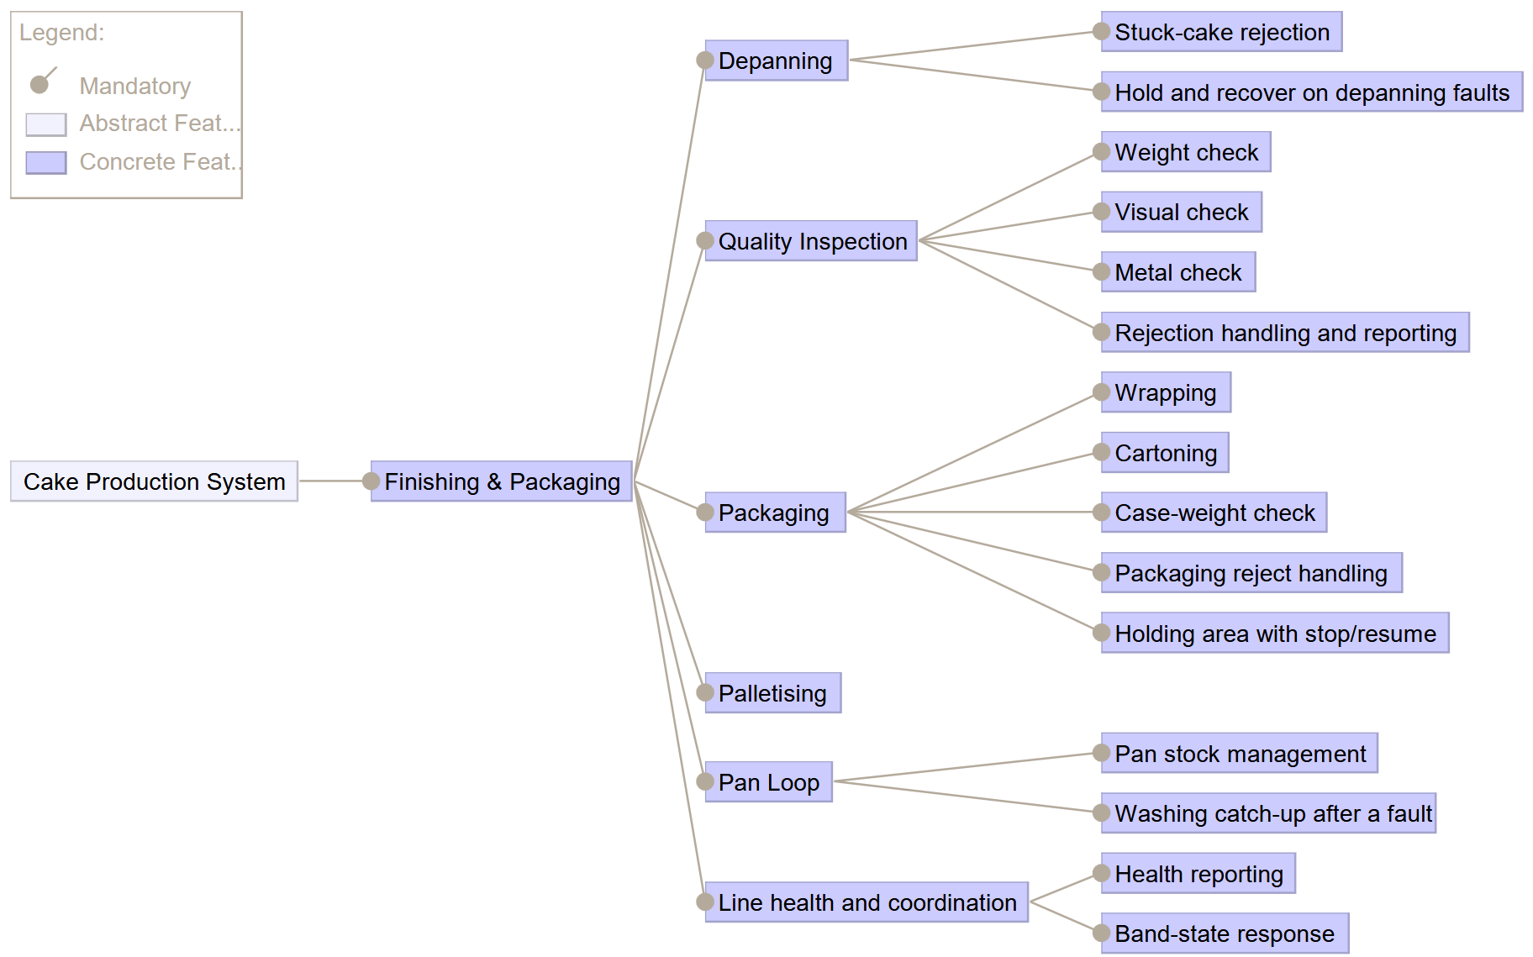

Analysis Blocks

Analysis Functions
ID | Analysis function | Responsibility | Inputs | Outputs | Devices used | Features | Requirements
FIN-AF-01 | Depanning Control | Accept cooled cakes released by Thermal Processing; separate cake from pan; route cake to inspection and pan to washing; reject stuck or broken cakes; hold cakes while the depanning machine is down and process them after Repair confirmed. | Cooled cake (cake, batch ID); band commands from Band-State Response; Repair confirmed | Depanned cake; empty pan; rejected-cake information to Event Reporting | Vision-Guided Picker | 01, 02, 03 | 01, 02, 04, 31, 32
FIN-AF-02 | Batch Tracking | Keep the batch ID with every cake from arrival until it is on a pallet. Cross-cutting: not one feature of its own. | Batch ID at intake | Batch ID to Event Reporting and Pallet Packing Control | none | cross-cutting (01, 08, 15) | 03
FIN-AF-03 | Weight Check | Weigh each depanned cake and judge it against the regulatory tolerance. | Depanned cake; target weight and tolerance (open interface) | Weight result (pass / fail) | Weight-Checker | 05 | 05
FIN-AF-04 | Visual Check | Inspect the appearance of each cake. | Depanned cake | Visual result (pass / fail) | Visual Inspection Camera | 06 | 06
FIN-AF-05 | Metal Check | Scan each cake for metal contaminants; notify Food Quality Control when metal is found. | Depanned cake | Metal result (pass / fail); notification to Food Quality Control | Metal Detector | 07 | 07, 10
FIN-AF-06 | Inspection Decision & Reject Handling | Combine the three results; let a cake proceed to packaging only if it has not failed; move every failed cake to the reject bin. | Weight, visual and metal results | Passed cake to Wrapping Control; failed cake to reject bin; failure information to Event Reporting | Reject Bin with diverter | 08 | 08
FIN-AF-07 | Wrapping Control | Wrap each inspected cake and verify the wrapping. | Passed cake; band commands | Wrapped cake; wrapping result | Wrapping Station; Wrapping Camera | 10 | 21
FIN-AF-08 | Cartoning Control | Pack each wrapped cake in a carton, seal it and verify the carton. | Wrapped cake | Cartoned cake; cartoning result | Cartoning Station; Cartoning Camera | 11 | 23
FIN-AF-09 | Case Weight Check | Weigh each sealed case and set aside cases with an incorrect weight for manual check. | Sealed case | Case OK, or case set aside; set-aside information to Event Reporting | Case Weight-Checker | 12 | 25
FIN-AF-10 | Packaging Reject Handling | Let only properly wrapped and properly cartoned cakes proceed to the shipping bin; send all others to the refuse bin. | Wrapping result; cartoning result | Cake to Pallet Packing Control, or to refuse bin; discard information to Event Reporting | Refuse Bin with diverter | 13 | 24
FIN-AF-11 | Holding Area Management (optional) | Hold incoming cakes while the wrapping station is unavailable; release them after Repair confirmed; tell Thermal Processing to stop or resume pan admission. | Wrapping station status; holding-area fill level; Repair confirmed | Held cakes released to Wrapping Control; Stop / resume pan admission | Holding Area | 14 | 33, 34, 35
FIN-AF-12 | Pallet Packing Control | Place cartoned cakes on the current pallet; when full, set it aside for wrapping and stage a new empty pallet; wrap the full pallet; announce it ready for shipment. | Cartoned cake; batch IDs | Pallet ready for shipment (pallet ID, cake count, batch IDs) | Palette Packer; Pallet Wrapper | 15 | 27, 28, 29, 30
FIN-AF-13 | Pan Washing Control | Wash, dry and verify empty pans; queue passing pans for recirculation; remove failing pans; accept pans diverted by Thermal Processing. | Empty pans from Depanning Control; Pan for washing; speed command from Washing Catch-up | Clean pans to Pan Stock Management; discarded-pan information to Event Reporting | Washing Station; Discard Bin | 17 | 11, 12, 15
FIN-AF-14 | Pan Stock Management | Keep the pan total at twice what the full system needs; supply a clean pan on request; report the stock level; keep supplying from stock while washing is down. | Clean pans from Pan Washing Control; Pan request | Clean pan supply (pan, stock level) | Pan Hopper | 18 | 14, 16, 17, 18
FIN-AF-15 | Washing Catch-up (optional) | After a washing fault: resume only when all conditions are met, wash faster while a backlog remains, return to normal speed afterwards, log each speed change. | Repair confirmed; backlog level; continue-conditions | Speed command to Pan Washing Control; speed-change log | none | 19 | 19, 20
FIN-AF-16 | Health Reporting | Publish a status for every function and device in the slice at a regular interval. | Status of all functions and devices | Machine status (heartbeat) | none (reads all devices) | 21 | 36
FIN-AF-17 | Band-State Response | On band halt: finish product already inside and accept no new product. On slow-down: keep working at reduced speed. On restart: resume normal processing. | Band state change | Continue / hold / resume commands to the intake functions | none | 22 | 37, 38
FIN-AF-18 | Event Reporting | Publish one log, warning, error or discard event (reason, time, batch ID, metal flag) for every failed cake, rejected or discarded cake, discarded pan and set-aside case. Central design choice. | Failure and discard information from Depanning Control, Inspection Decision, Case Weight Check, Packaging Reject Handling, Pan Washing Control; batch ID from Batch Tracking | Log, warning, error and discard events | none | cross-cutting (02, 08, 12, 13, 17) | 09, 13, 26

Functional Devices
ID | Device | Kind | Used by | Source | Note
FIN-FD-01 | Vision-Guided Picker | Sensor and actuator | Depanning Control | UC11, FC21
FIN-FD-02 | Weight-Checker | Sensor | Weight Check | UC13 | One name to be agreed for the weight sensor
FIN-FD-03 | Visual Inspection Camera | Sensor | Visual Check | UC13
FIN-FD-04 | Metal Detector | Sensor | Metal Check | UC13
FIN-FD-05 | Reject Bin with diverter | Actuator | Inspection Decision & Reject Handling | UC13, FC24
FIN-FD-06 | Wrapping Station | Actuator | Wrapping Control | UC14/15, FC25
FIN-FD-07 | Cartoning Station | Actuator | Cartoning Control | UC14/15
FIN-FD-08 | Case Weight-Checker | Sensor | Case Weight Check | FC26
FIN-FD-09 | Refuse Bin with diverter | Actuator | Packaging Reject Handling | UC14/15
FIN-FD-10 | Holding Area | Buffer | Holding Area Management | FC25 | Optional (FEAT-14)
FIN-FD-11 | Palette Packer | Actuator | Pallet Packing Control | UC16
FIN-FD-12 | Pallet Wrapper | Actuator | Pallet Packing Control | UC16 | Called the wrapping station in UC16; renamed to avoid a clash
FIN-FD-13 | Washing Station | Actuator | Pan Washing Control | UC12, FC23
FIN-FD-14 | Discard Bin (pans) | Actuator | Pan Washing Control | UC12
FIN-FD-15 | Pan Hopper | Buffer | Pan Stock Management | UC12
FIN-FD-17 | Wrapping Camera | Sensor | Wrapping Control | UC14/15
FIN-FD-18 | Cartoning Camera | Sensor | Cartoning Control | UC14/15

External Ports
Signal | Direction | Owning analysis function | Change to interface table
Cooled cake | In | Depanning Control | Replaces "Depanning Controller"
Pan request | In | Pan Stock Management | Replaces "Washing Station Controller"
Pan for washing | In | Pan Washing Control | Replaces "Washing Station Controller"
Clean pan supply | Out | Pan Stock Management | Replaces "Pan Washing & Supply"
Stop / resume pan admission | Out | Holding Area Management | Replaces "Wrapping Station Controller"
Log, warning, error and discard events | Out | Event Reporting | Replaces "Quality Inspection Control"
Machine status (heartbeat) | Out | Health Reporting | Replaces "Each station controller"
Band state change | In | Band-State Response | Replaces "Station controllers"
Repair confirmed | In | Depanning Control; Holding Area Management; Washing Catch-up | New signal (not in the original table)
Pallet ready for shipment | Out | Pallet Packing Control | Replaces "Pallet Packing"

Block Definition Diagrams (BDDs)

Pan Loop
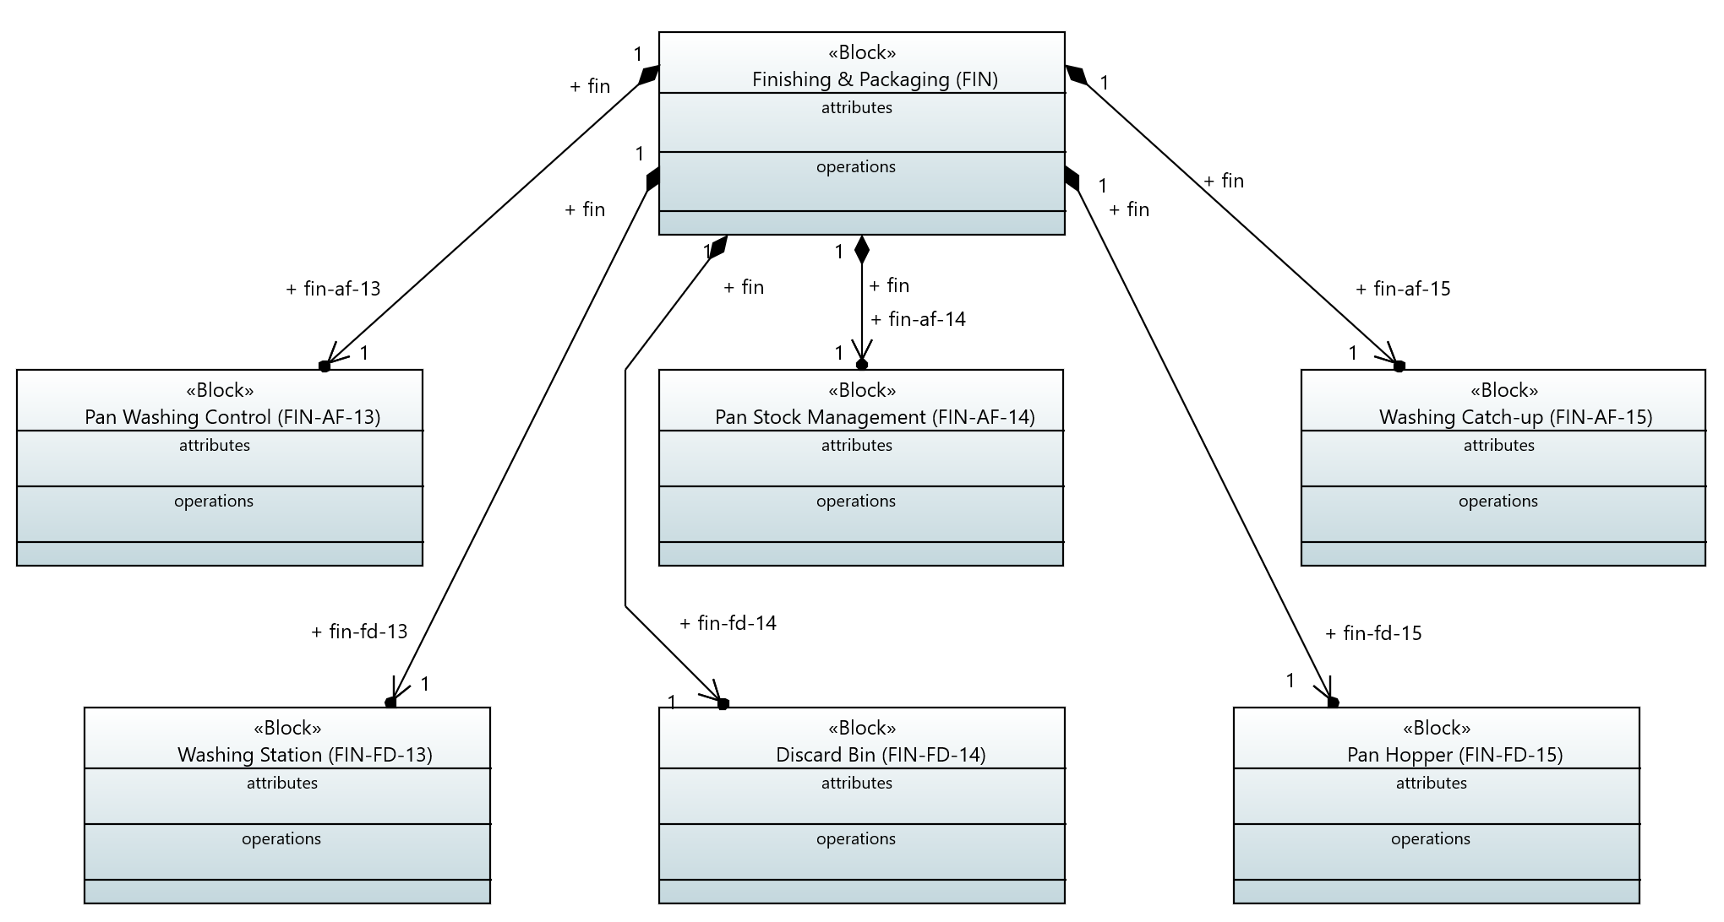

Inspection
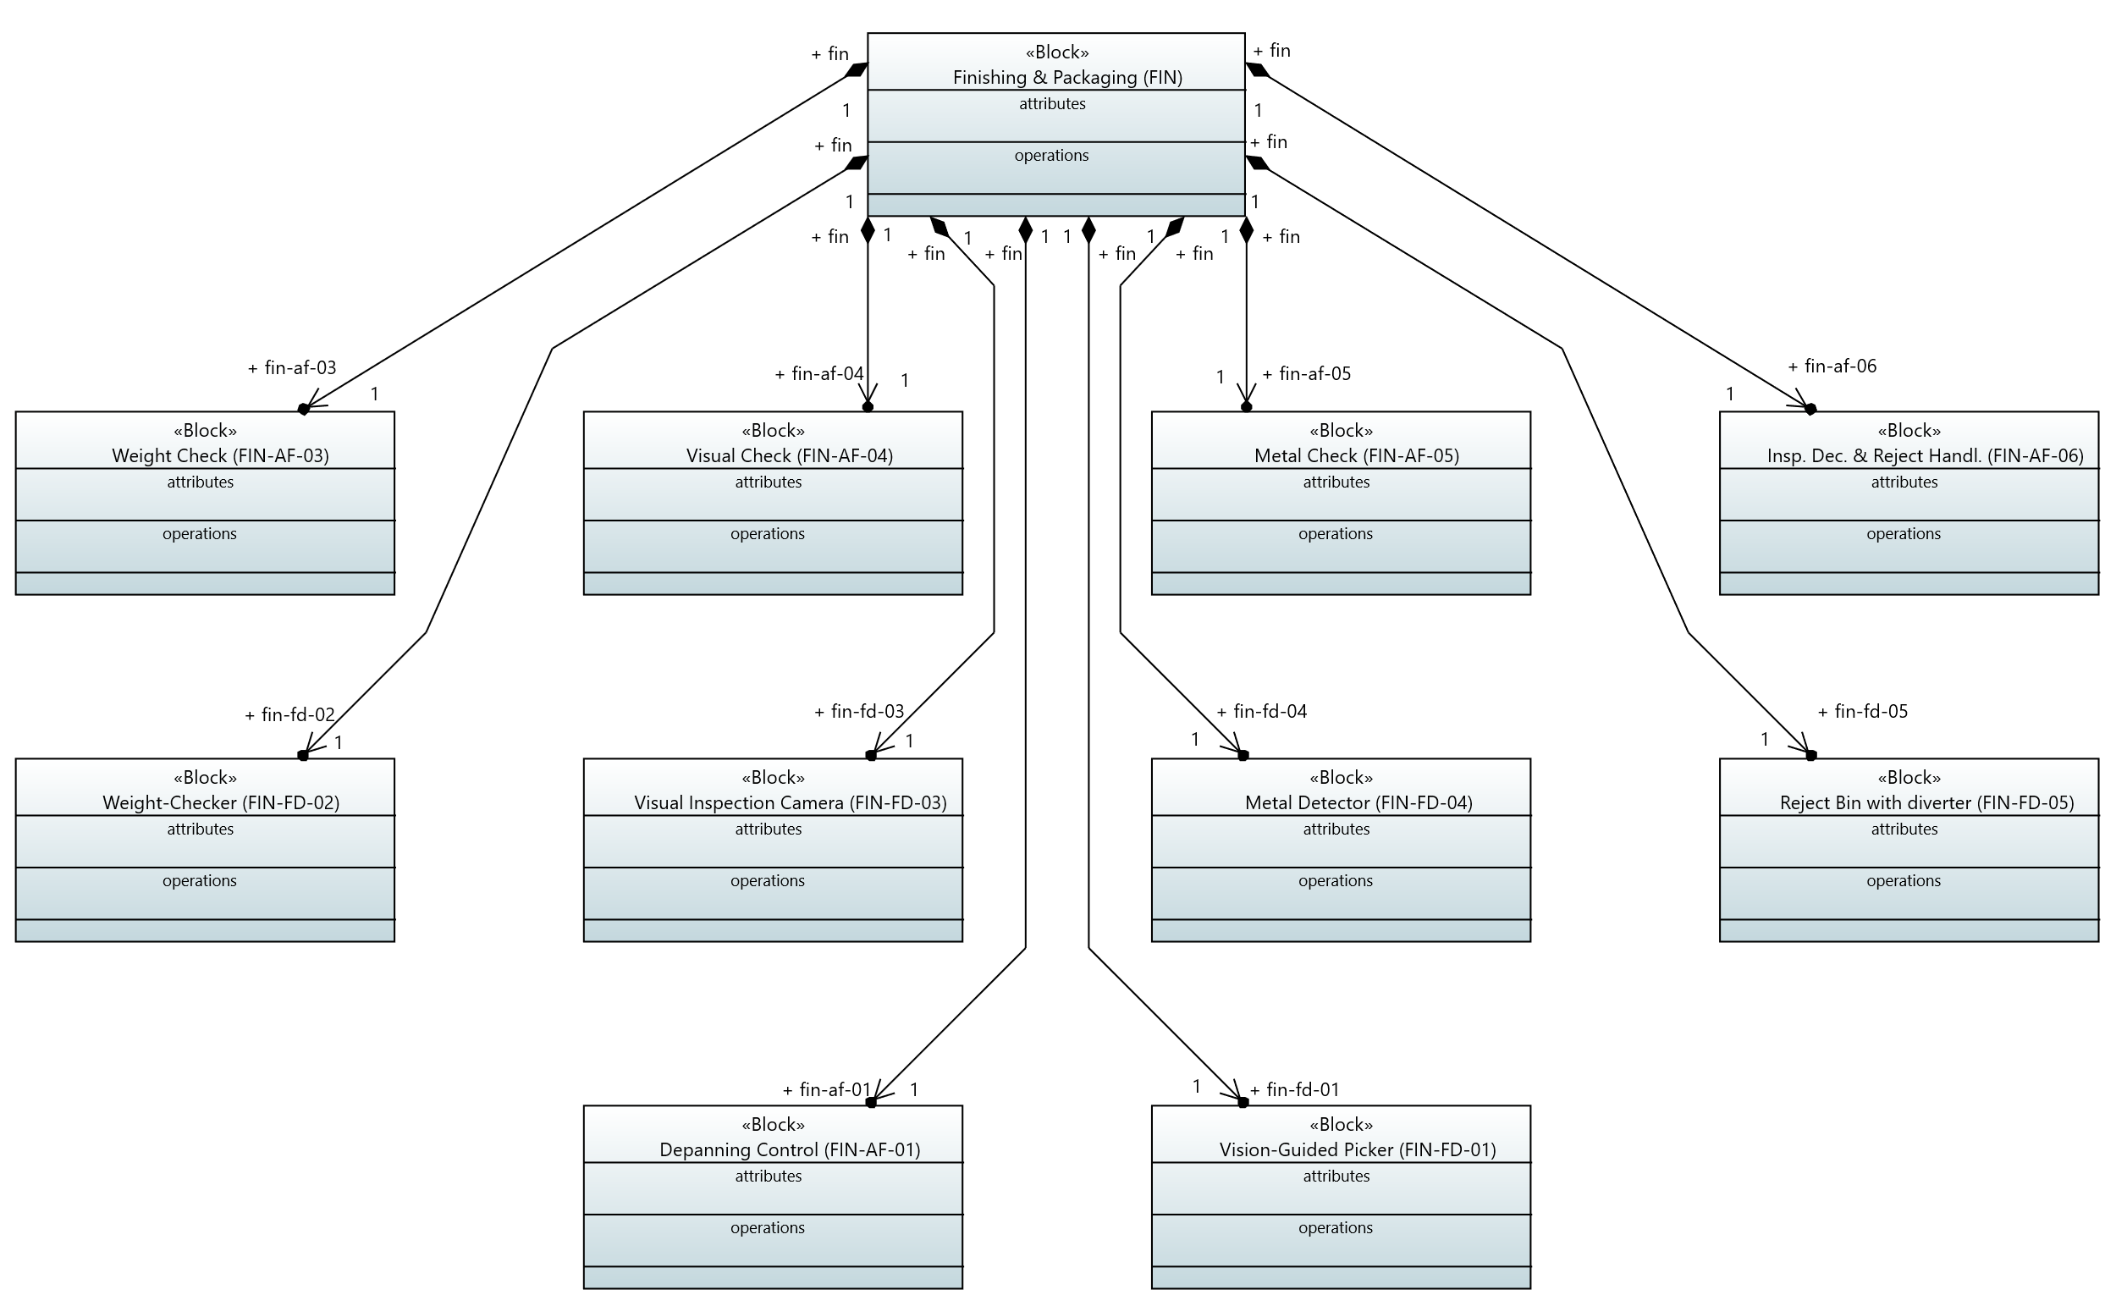

Packaging
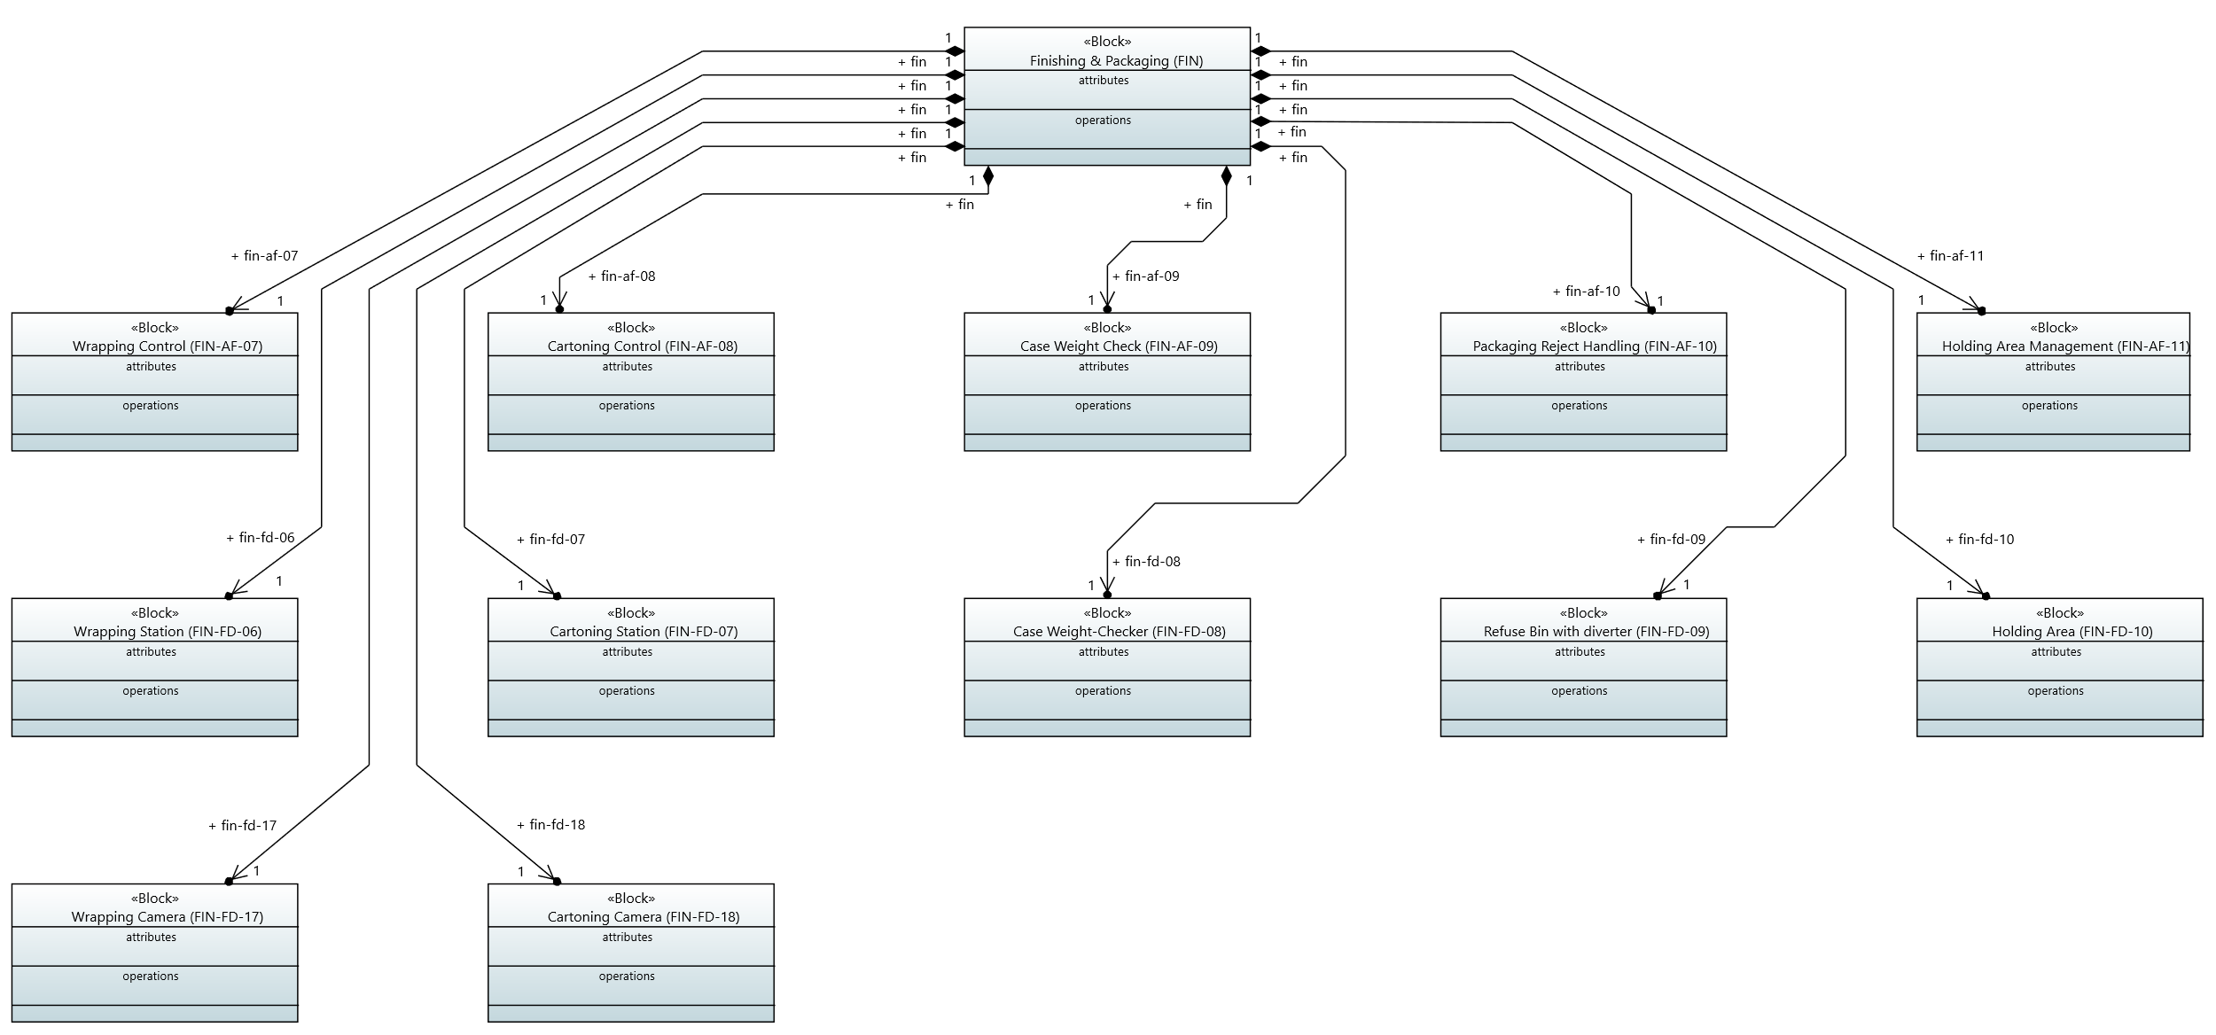

Palletising
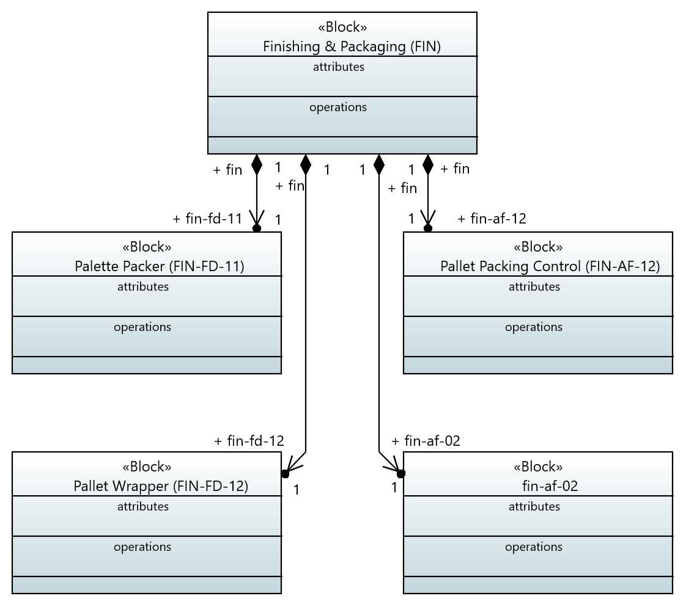

Reporting
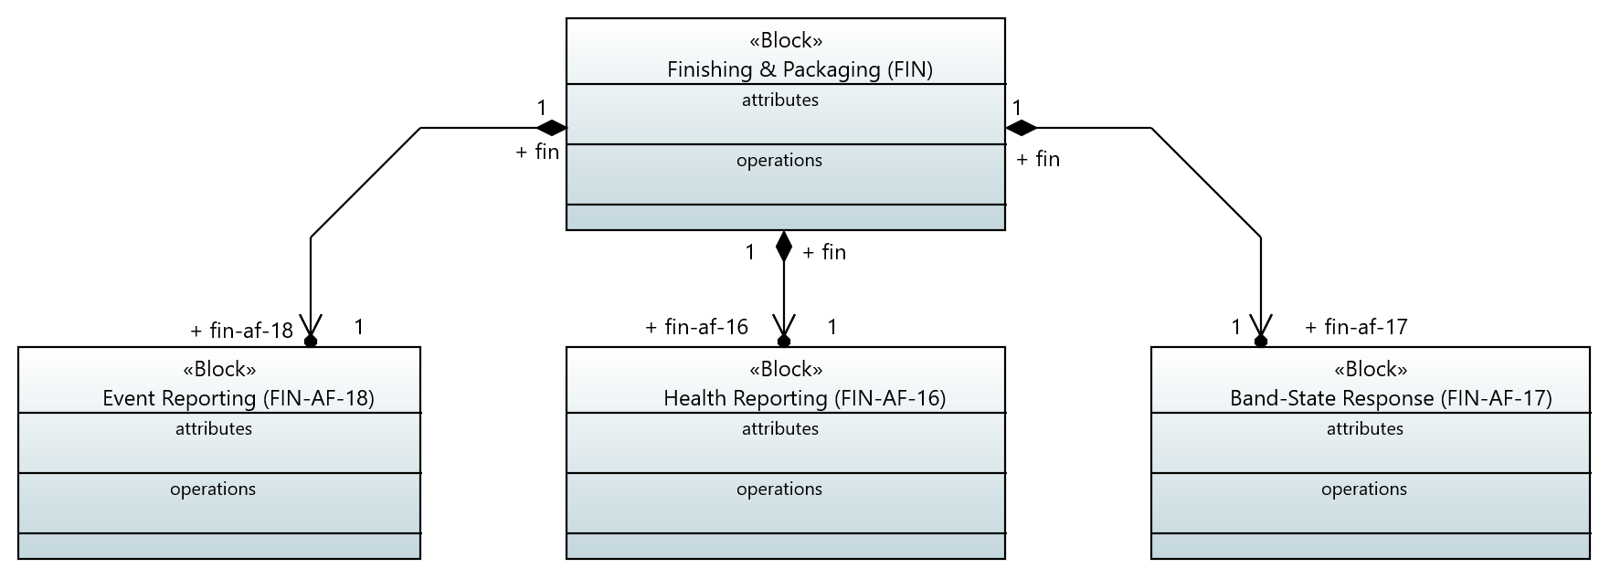

Internal Block Diagrams (IBDs)

Pan Loop
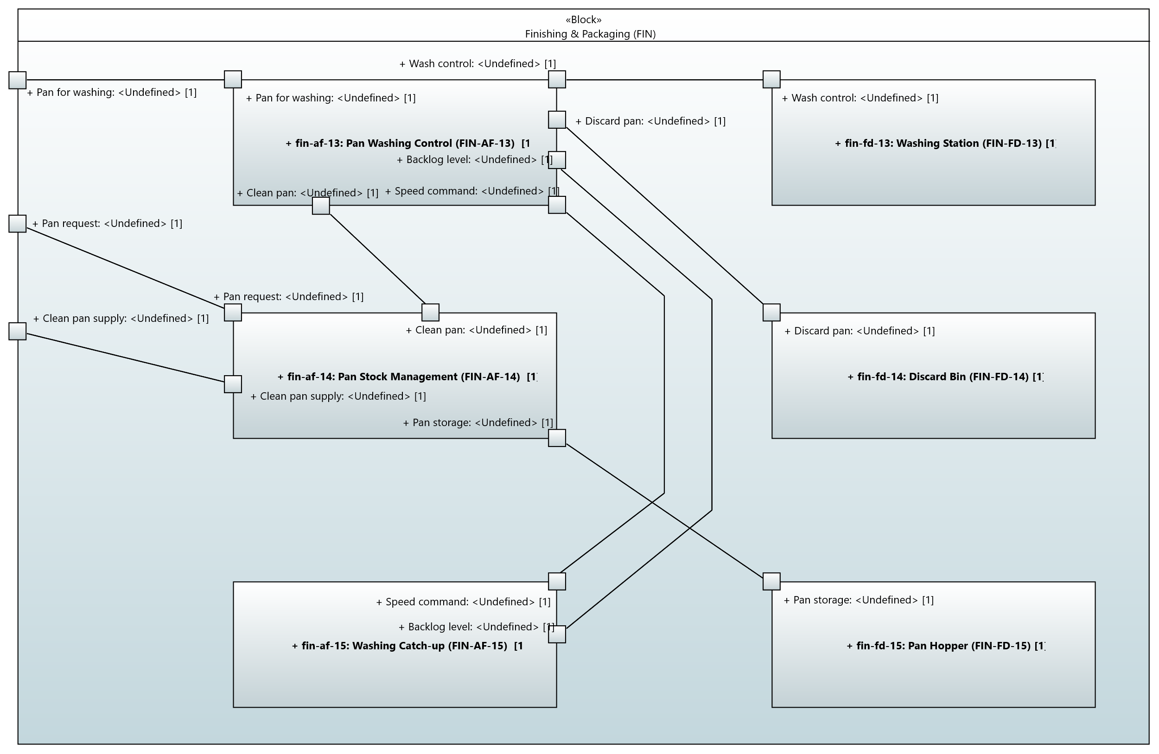

Inspection
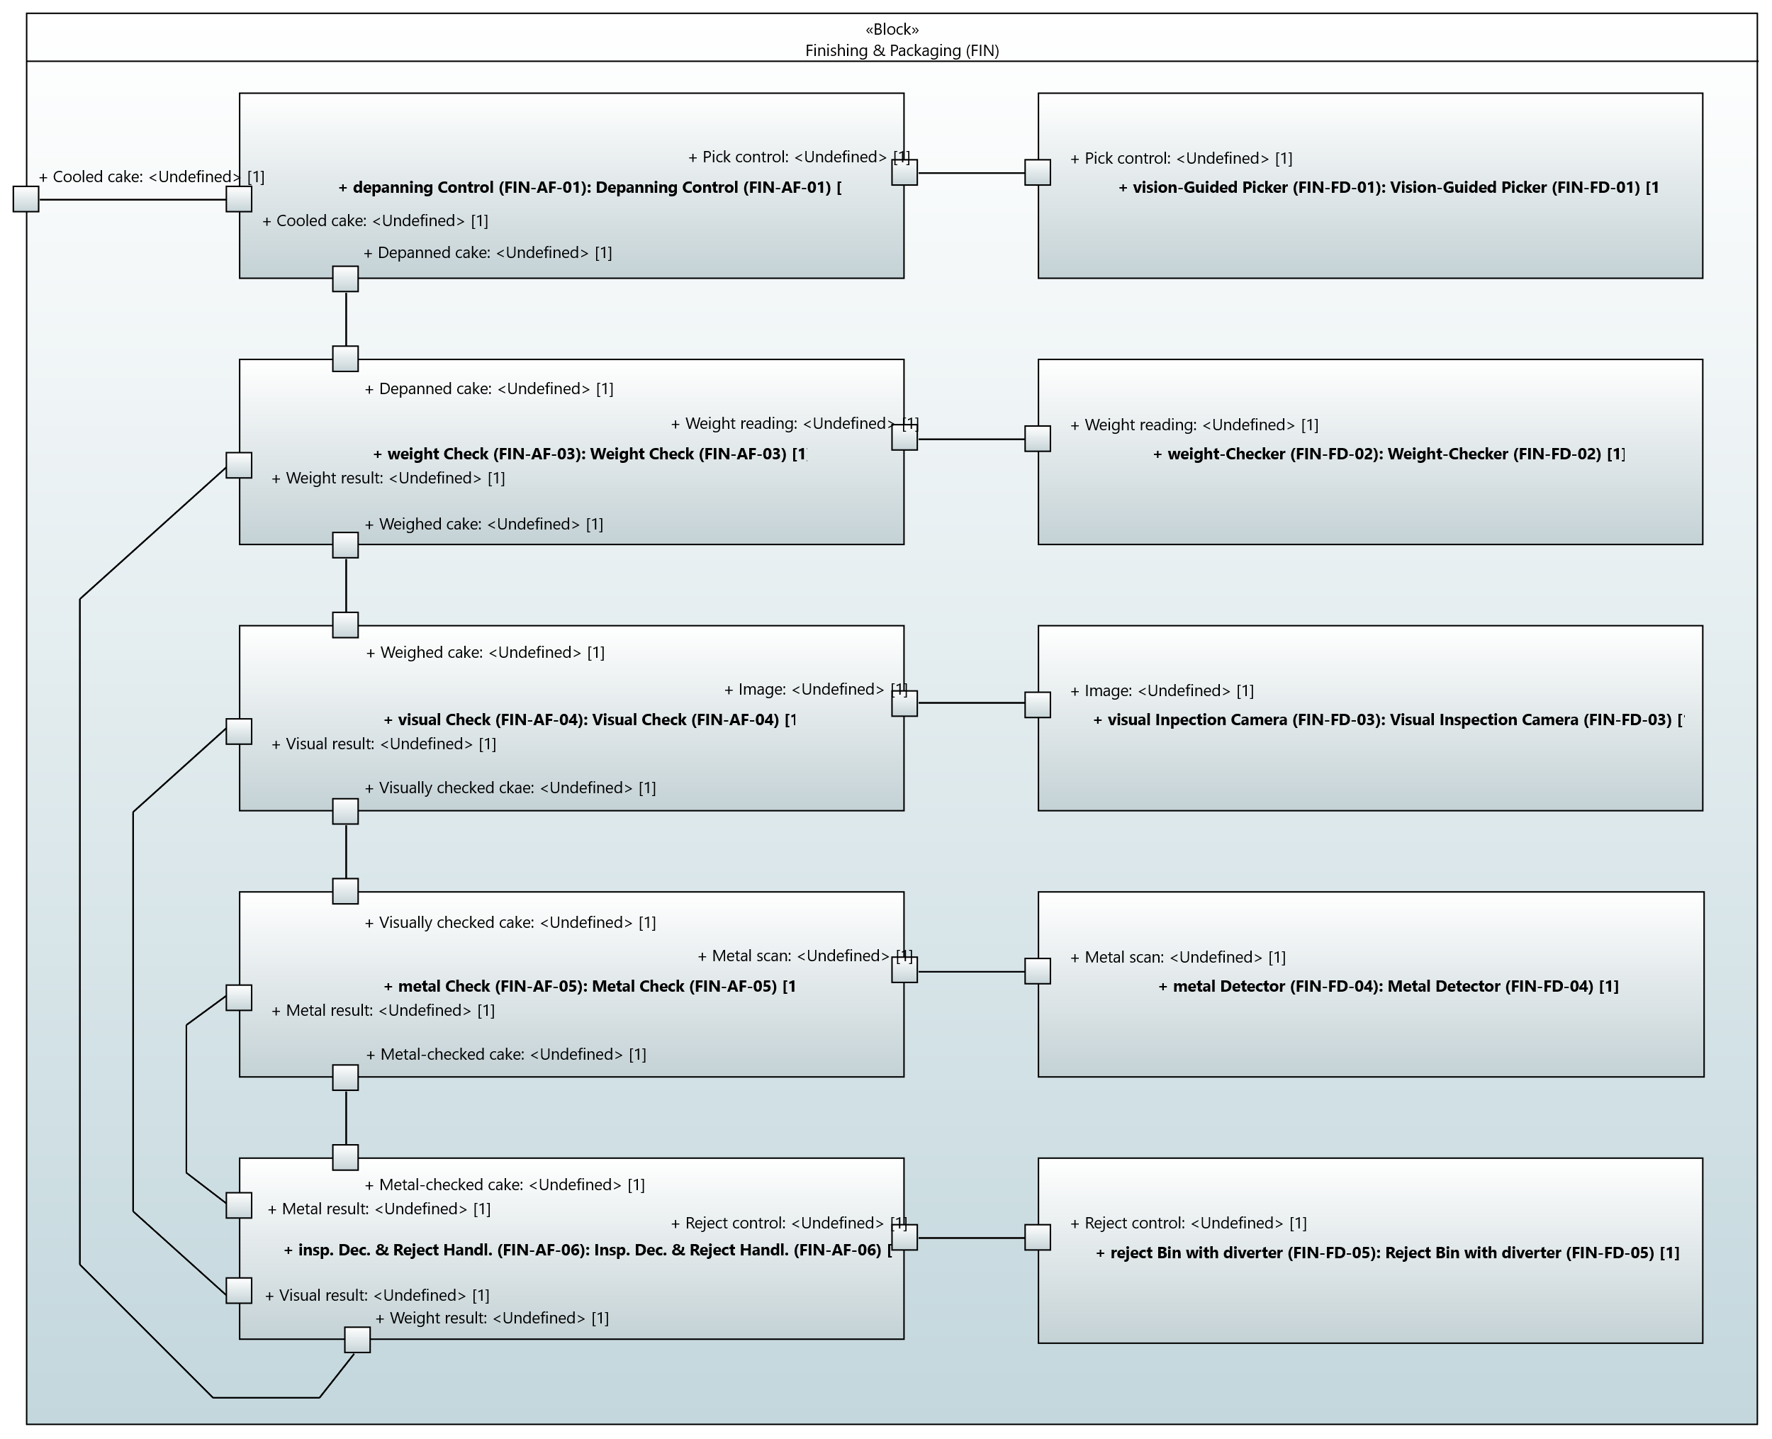

Packaging
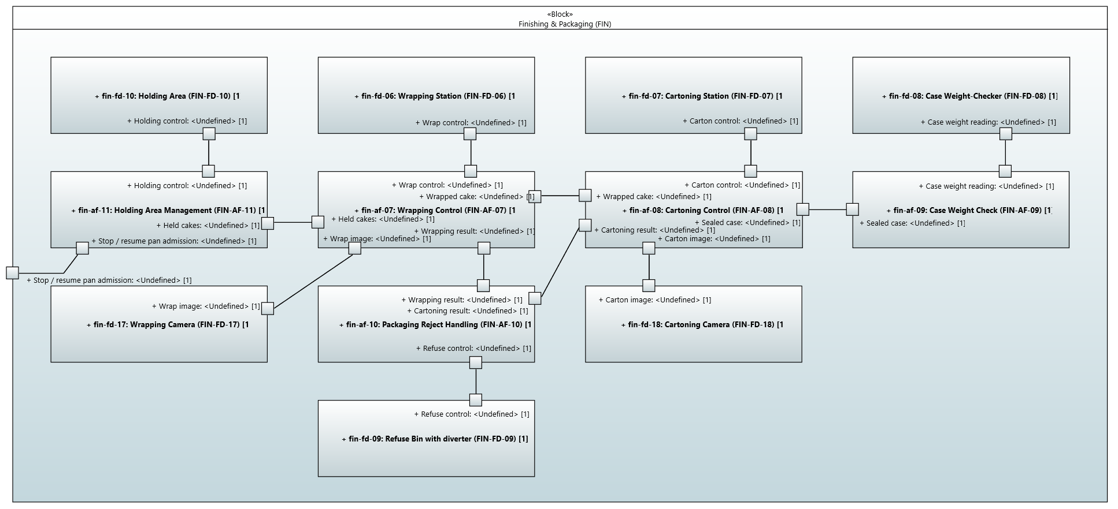

Palletising
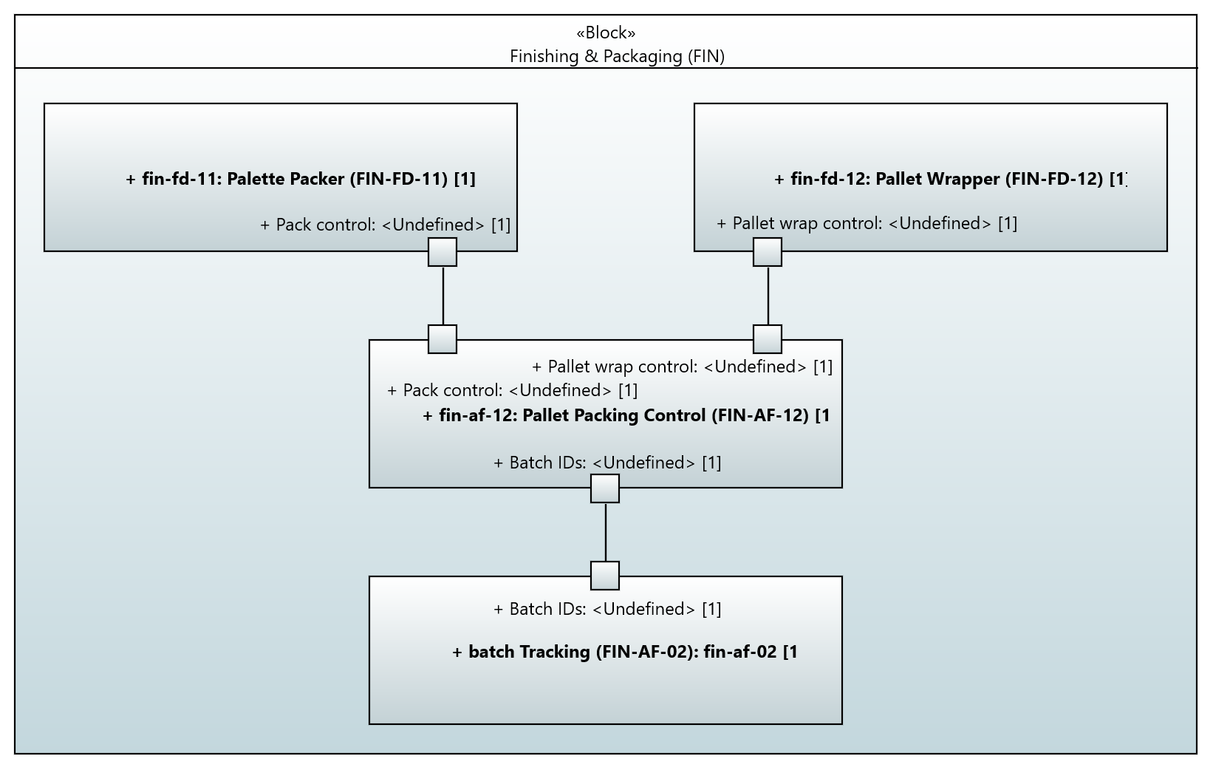

Reporting
